North Lincolnshire Council
Daily Event Analysis
8th, 9th & 10th October 2010

Overview
The weekend of the 8th, 9th & 10th October saw a number of monitoring sites around the Scunthorpe Town area exceed the allowed 50µg/m³ as a daily mean. A check of the data has revealed that concentrations of PM₁₀ were above the objective throughout the day at most sites due in part to the extended period of Easterly winds. During this 72 hour period concentrations around the Town consistently measured above 60µg/m³.

Site | 8th October | 9th October | 10th October
Amvale (Osiris) | 85µg/m³ | 76µg/m³ | 105µg/m³
Redbourne Club (TEOM) | 69µg/m³ | 66µg/m³ | 53µg/m³
Scunthorpe Town (TEOM) | 64µg/m³ | 59µg/m³ | 50µg/m³
East Common Lane (TEOM) | 80µg/m³ | 74µg/m³ | 73µg/m³
Station Road (Osiris) | 64µg/m³ | 47µg/m³ | 46µg/m³
Lincoln Gardens TEOM | 40µg/m³ | 56µg/m³ | 52µg/m³

Met Conditions
Consistent E winds were observed throughout the weekend. The wind for the 72hr period ranged between 24° and 113°. Wind speeds averaged at 3.7 m/s. The highest wind speed of the weekend was 5.7m/s. No rain was measured throughout the day.

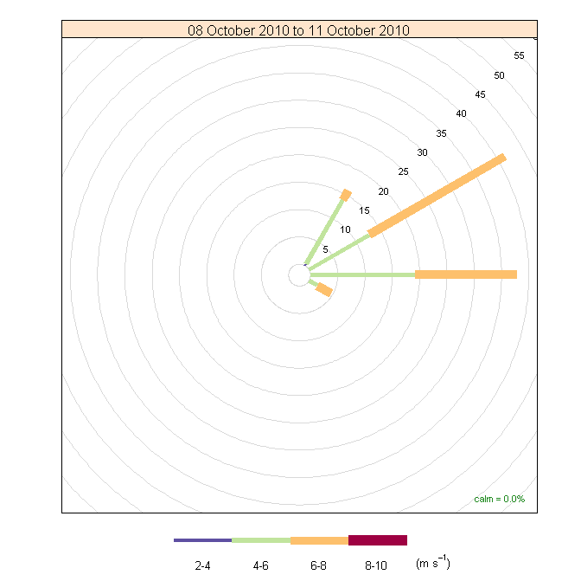

Appleby & Santon were both checked to ensure that this was not a regional event. Neither sites was subject to exceedances over this 72 hour period highlighting the likelihood that the particulate matter was lifted from within or near the Integrated Works.

Episode Wind Range

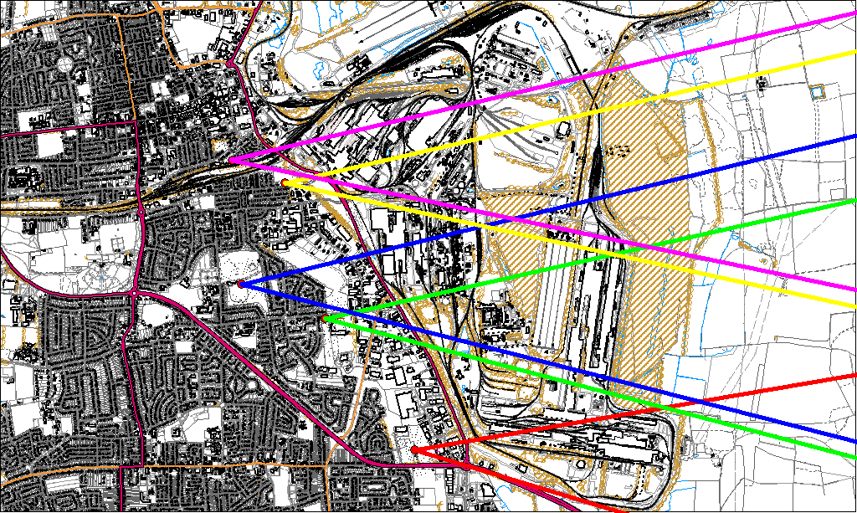
8th October
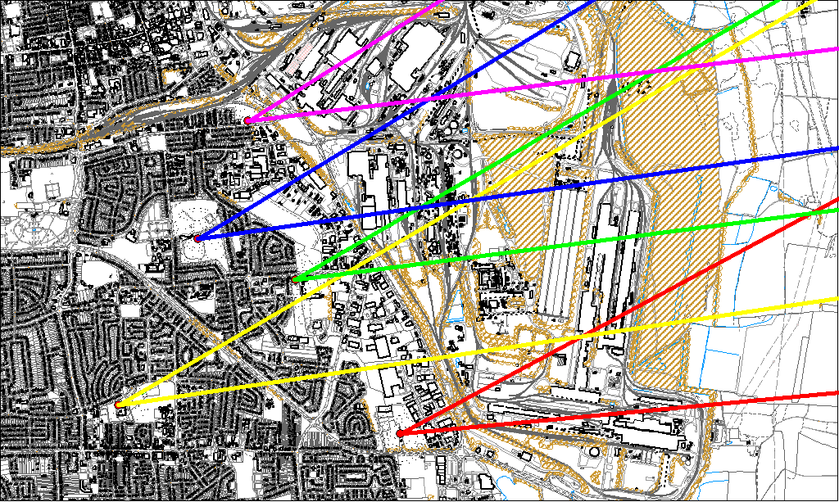
9th October

Potential Sources
Due to the vast area in which these wind ranges cover it is difficult to identify an individual area in which the problem has arisen. The furthest North site, Station Road, experienced its first exceedance during this period but was unlikely to have been affected by the same source that was affecting the furthest South monitoring station, Amvale.

This serves to highlight the dependence a Scunthorpe wide exceedance is on a period of Easterly winds.

